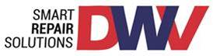

COVID 19

From: Darren Fletcher, Group Health, Safety & Facility Manager
To: DWV Employees
Date: 30th November 2021 (updated from 16th September 2021)
Location: Dent Wizard Ventures Ltd, Unit 3, City Park Estate, Gelderd Road, Leeds, LS12 6DR

The World Health Organisation has identified that COVID-19 is not an airborne virus.

Respiratory infections can be transmitted through droplets of different sizes. When the droplet particles are above a certain size they are referred to as respiratory droplets, and when then are below a certain size, they are referred to as droplet nuclei.

According to current evidence, COVID-19 virus is primarily transmitted between people through respiratory droplets and contact routes including touch points. What this means in practice is, the droplets are of a weight that they will fall to the ground at around 1 metre, thus the 2-metre social distancing rule.

They can remain on surfaces for some time depending on type of material. Therefore, the three main methods of preventing the spread of infection being hygiene measures, facemasks and social distancing.

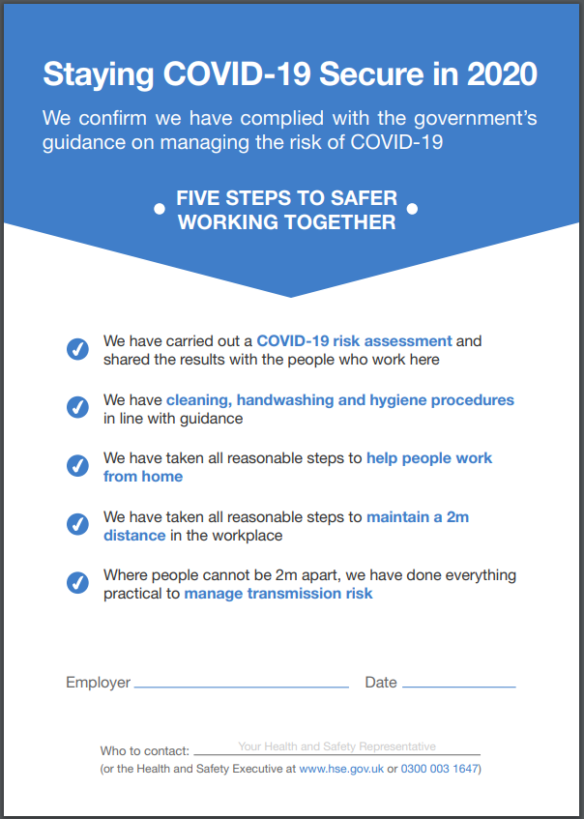
1st June 2020
Darren Fletcher
Car Care Plan

COVID-19 Outbreak Plan
Car Care Plans COVID-19 Incident Response process is well established and will be implemented where there is a confirmed COVID-19 outbreak within the workplace. The Single Point of Contact (SPOC) is Chris Wood, with Darren Fletcher as the alternate. The COVID-19 Incident Response Team has been meeting on a weekly basis since 17 March 2020. The members are: Chief Executive Officer, Chief Financial Officer, Chief Operations Officer, Chief Risk Officer, Health and Safety Manager, Head of Operations, HR Business Partner and IT Business Partner.
In the event of a confirmed positive case at Dent Wizard Ventures, the SPOC will immediately communicate with all employees, contractors or visitors to the office who may have had contact with the individual testing positive, advising them to either remain at home, or to go home where they are in the office. The employees will be asked to self-isolate until they receive further information.
The SPOC will communicate with the appropriate Local Government Public Health departments:
- Jubilee House, The Courtyard and DWV location – call 0113 222 4444 or phrc@leeds.gov.uk
- Manchester location – call 0344 225 0562 (select option 3) or email mft.central.coordinationcentre@nhs.net
Car Care Plan’s COVID-19 Incident Response Team will convene within 60 minutes of the confirmed COVID-19 case being communicated to the business and regularly thereafter. Template correspondence have been created to allow for consistent messaging with employees where there is an outbreak within the business. Next steps will be agreed by the Incident Response Team, which will include (as a minimum) agreement on:

- Staff communications
- Office closure(s)
- Office cleaning
- Client communications
- Customer communications
- Response from PHE / NHS
- Testing support for employees
- Communication with other stakeholders – e.g. regulators, press, suppliers etc.

Minutes of the Incident Response Team meetings will be taken and regular updates will be provided to the relevant Board(s) and shareholders.

What are the hazards | Who might be at risk and how | What are we already doing to control the risks | What additional actions can we take to control the risks | Action required by who | Action required by when | Completed
Employers Liability Insurance provides insufficient cover | Employees &  business reputation | Suitable Employers Liability Insurance is in place  Commencement of Insurance –  31st December 2020  Date of Expiry –  30th December 2021 | Inform insurer of our return to work and following all government guidelines. | No further action required | n/a | Yes
No formal COVID return to work risk assessment completed and shared with all employees | Employees & visitors  Employers have a legal duty to assess the risks to the health and safety of employees and communicate with the employees | Car Care Plan Group hold COVID meetings each Monday morning to assess to the impact to the business operations, employee and customer risks  This formal risk assessment has been produced on Government guidelines and the COVID meetings | Continue to follow Government guidelines with internal COVID meetings to manage the associated risks  Share the risk assessment with all employees and gain feedback  Continue to review and update the risk assessment | Darren Fletcher | Reviewed weekly | Yes
Risk assessments  for  Workstation, Home Working, Pregnancy and Fire Safety | Employees & visitors  Employers have a legal duty to assess the risks to the health and safety of employees and communicate with the employees | Risk assessments progress weekly with employees to remove or manage any risks. The risk assessments are reviewed, discussed and agreed with the employee / manager to ensure the risks remain low | Fire officer training and the number of fire officers is being reviewed to ensure DWV have a suitable number of competent officers to manage the safety evacuation in normal operational hours (Monday to Friday), late working and weekends.  A fire evacuation test will commence when employees return to the office or throughout July 2021.  21 employee workstation risks assessments completed for employees WFH. | Darren Fletcher | Reviewed weekly | Yes
Employees coming to work if they think they or anyone in their household has COVID 19 symptoms.  The symptoms are:  - A high temperature  - A new, continuous cough  - A loss of, or change to, your sense of smell or taste | Employees and team members working within the business  Business operations due to the spread of the virus | Employees are making their manager, HR or Compliance aware prior to them coming to work.  If the employee or anyone in their household has COVID 19 symptoms the employee will not return to the office | - All employees intending to work from the office will be required to complete an attestation in relation to self-isolating where they have any symptoms  - Monitor the employee’s situation  - Provide the employee with the following advice lines  - www.gov.uk/coronavirus  - Use the NHS 111 online coronavirus service | Management team | The action will be discussed with the returning employee on each return to work | 16th Sept 2021
No induction process or poor guidance provided to the employee’s prior to returning to work | Employees working within the business  Business reputation  Limited or no induction on arrival back to the working environment may cause anxiety and unrest | A comprehensive one to one or group virtual return to work induction will take place with all employees at an agreed date / time prior to the employee arriving back to work.  The induction process will cover.  - All employees must sanitise their hands on arrival to the office. Sanitising gel is available on arrival at the office and sanitising gel is situated in ad-hoc areas across the office and warehouse  - All employees must continue to social distance whilst in the office | - Support and monitor employee’s arrival back to work  - Monitor PPE stock levels | Department manager, Compliance & H&S team | Review daily | Ongoing with daily review
Hands  Employees or visitors not sanitising their hands on arrival to the office | Employees working within the business  Not using hand sanitiser gel on arrival to the office and regularly throughout the day. | Sanitising of hands is discussed with each employee at induction  Employees and visitors must sanitise their hands on arrival to the premises  Hand sanitising stations are placed throughout the office environment | While coronavirus is not likely to survive for long periods of time, it can live for more than 24 hours in indoor environment  Suitable signage is visible to remind employee and visitors to sanitise their hands | Management team | Review daily | 16th Sept 2021
Face masks / face coverings  Employees or visitors not wearing a face mask or face cover when walking around the internal office space | Employees working within the office environment  Visitors coming to the DWV premises during the coronavirus (COVID-19) pandemic | Face coverings and face masks are discussed with each employee at induction  Employees and visitors must wear a face mask when walking around the internal office space to protect themselves and others  Face masks are also available from the reception area | Larger droplets can land on other people or on surfaces they touch while smaller droplets, called aerosols, can stay in the air indoors for at least 5 minutes  Internal office cleaning will continue early morning, throughout the day and a deep clean each evening  Suitable signage is visible around the office to remind employee and visitors to wear a face mask | Management team | Review daily | 30th November 2021
Space  Employees or visitors not maintaining the  2 metre space | Employees working within the business  Not keeping the exact distance isn’t always possible, remaining mindful of surroundings and continuing to make space has a powerful impact when it comes to containing the spread of the virus | Maintaining a 2-metre space (or 1m+ when wearing a facemask) is discussed with each employee at induction and prior to returning to the working environment | Transmission of the virus is most likely to happen within 2 metres, with risk increasing exponentially at shorter distances  Suitable signage is positioned around the offices | Management team | Review daily | 16th Sept 2021
Building Environment Ventilation System  Ventilation system not suitable for the work environment.  Poor management and maintenance | Employees working within the business  Business reputation  Poor ventilation or lack of maintenance could restrict the fresh air supply within the office environment | The City Park environment does not have a mechanical ventilation system. The environment benefits from opening windows and doors to allow fresh air into the internal environment. | Adequate ventilation reduces how much virus is in the air. It helps reduce the risk from aerosol transmission, when someone breathes in small particles (aerosols) in the air after a person with the virus has been in the same enclosed area.  - Ensure continual fresh air is maintained throughout operational hours at each office location | Darren Fletcher | Monthly | 16th Sept 2021
Building Environment – Air Conditioning  Poor management and maintenance | Employees working within the business  Business reputation  A lack of building maintenance could restrict the clean air supply within the office environment | DWV, City Park does not have an air conditioning system installed | - n/a | Darren Fletcher | n/a | 16th Sept 2021
Building Environment – Water Hygiene | Employees working within the business  Business reputation  Poor water hygiene controls can create water bacteria and legionella disease within the water system | Reviewing and updating the L8 risk assessments to ensure adequate controls are in place. | A weekly programme is in place to release the water from each tap and showers to prevent stagnant water build up in the plumbing systems. This arrangement commenced in March 2020.  Follow the controls and guidance from the L8 water risk assessment | Darren Fletcher | Monthly | 16th Sept 2021
Limited or poor office cleaning | Employees and visitors working within DWV premises  Limited or poor office cleaning increases the risk of infection to all employees, visitors and business operations | A new cleaning provider has been appointed to support the office cleaning within DWV premises  The office cleaning team will also focus on all key ‘touch points’ from entry to the premises, vending machines, photocopier, toilets and kitchen area  The cleaning team will operate Monday to Friday and be cleaning throughout the day with a deep evening clean  Cleaning equipment is available in the kitchen area and cross the office.  Employees are encouraged to wipe down tables and chairs after use. | Monitor the cleaning operative’s performance to ensure hot spots are cleaned regular  Daily stock checks of cleaning equipment to ensure cleaning supplies are maintained  Monthly meetings with the cleaning manager to review cleaning standards and contract | Cleaning operative, cleaning supervisor & management team | Weekly | 16th Sept 2021
Limited or poor directional signage | Employees working within the business  Business reputation | Clear signage is visible on arrival to the premises  Social distancing, face masks and PPE signs are placed in key ‘hot spot’ areas of the water machine, toilets and kitchen area. | Monitor the signage to ensure they remain visible, clean and do not become a trip hazard | Management team | Weekly | 16th Sept 2021
Unlimited access of all toilet areas which could spread the virus | Employees working within the business | - All toilets will remain open  - Hand wash soap and sanitiser gel is available in each toilet  - Hand wash signs are clearly visible at each toilet flush point  - Hand wash signs are clearly visible at each sink and water point | - Monitor the hand soap and sanitiser gel to ensure usage levels remain adequate  - Monitor the signage to ensure they remain clean and visible | Management team | Daily | 16th Sept 2021
Shower area | Employees working within the business | The shower will be available for use throughout the day.  The cleaning team will continue to monitor the shower area and carryout deep cleaning  - Storage lockers are available for employees to store away personal items, clothing and shower kits. | Monitor the shower areas daily for cleanliness and hygiene | Management team | Daily | 16th Sept 2021
Use of the kitchen / canteen area which could spread the virus | Employees working within the business | - Limited furniture is in the kitchen  - Hand wash soap and sanitiser gel is available in each kitchen area  - Social distancing and hand wash signs are clearly visible | Monitor the hand soap and sanitiser gel to ensure usage levels remain adequate  Monitor the signage to ensure they remain clean and visible | H&S Manager | Daily | 16th Sept 2021
Unlimited use of the meeting and training room which could spread the virus | Employees working within the business | Meeting rooms are available for use on a 50% reduced capacity  - Signage and seating availability is on view in each meeting room | Sanitiser gel and hygiene wipes are available in each meeting room | Management team | Weekly COVID review | 16th Sept 2021
Use of local printer | Employees working from the office | - Clear signage is placed on each machine to advise the user to clean the machine prior to use  - Hygiene wipes provided on each machine | - Monitor the signage to ensure they remain clean and visible  - Monitor the hygiene wipes to ensure we maintain stock levels | Management team, H&S team | Daily | 16th Sept 2021

PLEASE READ THE FOLLOWING STATEMENTS
I confirm that I have had a formal induction and I have reviewed and agreed to the attached risk assessment
I confirm I understand the social distancing rules and that I will ensure consider work colleagues when I the office environment.
I confirm that if I choose to wear a facemask, either my own or one provided by the company, that I am comfortable with the correct protocol for its use and do not need training on appropriate use and disposal.

https://www.who.int/images/default-source/health-topics/coronavirus/risk-communications/general-public/protect-yourself/infographics/masks-infographic---final.tmb-1920v.png

I confirm that if I wear disposable gloves, either my own or ones provided by the company, that I am comfortable with the correct protocol for their use and do not need training on appropriate use and disposal.
I confirm that I will follow all Government advice in relation to coronavirus, in particular the requirements surrounding self-isolation should I or any member of my household display any of the symptoms. I will inform my line manager immediately should self-isolation be required.

In addition, where I am required to self-isolate due to the Government track and trace requirements, I will inform my line manager immediately.

Name:

Signed:

Date:

